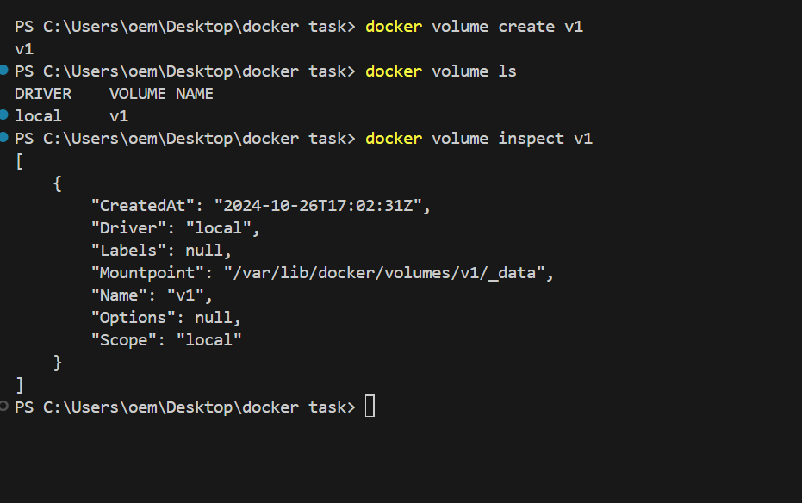

Cointainer 1

Cointainer 2

Creating file in container 1

Creating file in container 2



Container 3



Ls /data inside container3

